1. Write a program to print the sum of two numbers without using + operator. Other operators

can be used.

import java.io.\*;

class AddTwoNum

{

static int Add(int x, int y)

{

// Iterate till there is no carry

while (y != 0)

{

// carry now contains common set bits of x and y

int carry = x & y;

// Sum of bits of x and y where at least one of the bits is not set

x = x ^ y;

// Carry is shifted by one so that adding it to x gives the required sum

y = carry << 1;

}

return x;

}

// Driver code

public static void main(String arg[])

{

System.out.println(Add(10,17));

}

}

Output:-

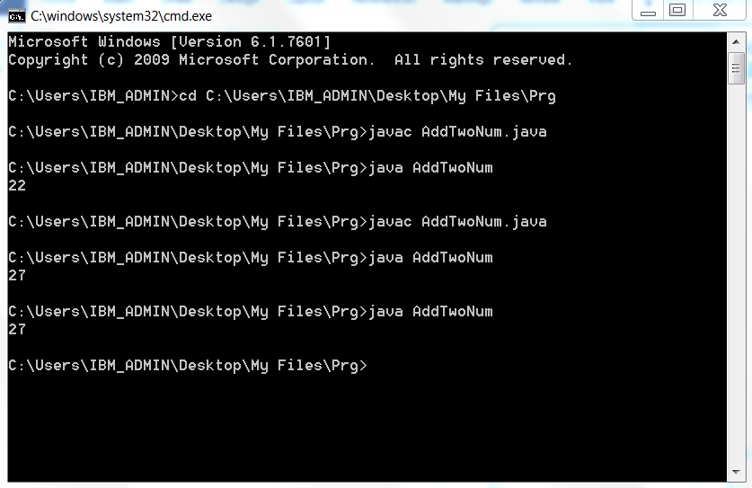

2. Write a program to print the result of the following expressions provided the integer variable

a is 20 and b is 10.

int b = a-- - --a;

int c = a--;

int d = a>>2;

int e = a&b;

public class Expressin

{

public static void main(String[] args)

{

int a=20, b=10; // initializing a and b

int c=a-- - --a;

int d=a--;

int e=a>>2;

int f=a&b;

System.out.println("The Value of c:" +c);//print the value of c

System.out.println("The Value of d:" +d);//print the value of d

System.out.println("The Value of e:" +e);//print the value of e

System.out.println("The Value of f:" +f);//print the value of f

}

}

Output:-

